SAVEETHA SCHOOL OF ENGINEERING
CSA15 - CLOUD COMPUTING AND BIG DATA ANALYTICS
Name: Edrin J S | Register Number: 192524041

EXPERIMENT 5
5. Create a simple cloud software application for Library book reservation system for SIMATS library using any Cloud Service Provider to demonstrate SaaS.

Aim
To develop a cloud-based Library Book Reservation System for the SIMATS Library using Zoho Creator and deploy it as a Software as a Service (SaaS) application, enabling students and staff to search, reserve, and manage library books online.

Procedure
- Log in to Zoho Creator using a valid Zoho account.
- Create a new application named SIMATS Library Book Reservation System.
Design forms such as:
  - Student Details
  - Book Details
  - Book Reservation
- Add required fields including Student ID, Student Name, Department, Email, Book ID, Book Title, Author, ISBN, Reservation Date, Due Date, and Reservation Status.
- Create reports to display available books, reserved books, overdue books, and student reservation history.
- Configure workflows for book reservation confirmation, availability validation, and return reminders.
- Assign user roles and permissions for librarians and students.
- Publish and deploy the application on the Zoho Creator cloud platform.
- Test the application by adding books, reserving books, updating reservation status, and viewing reports through a web browser.

Snapshots
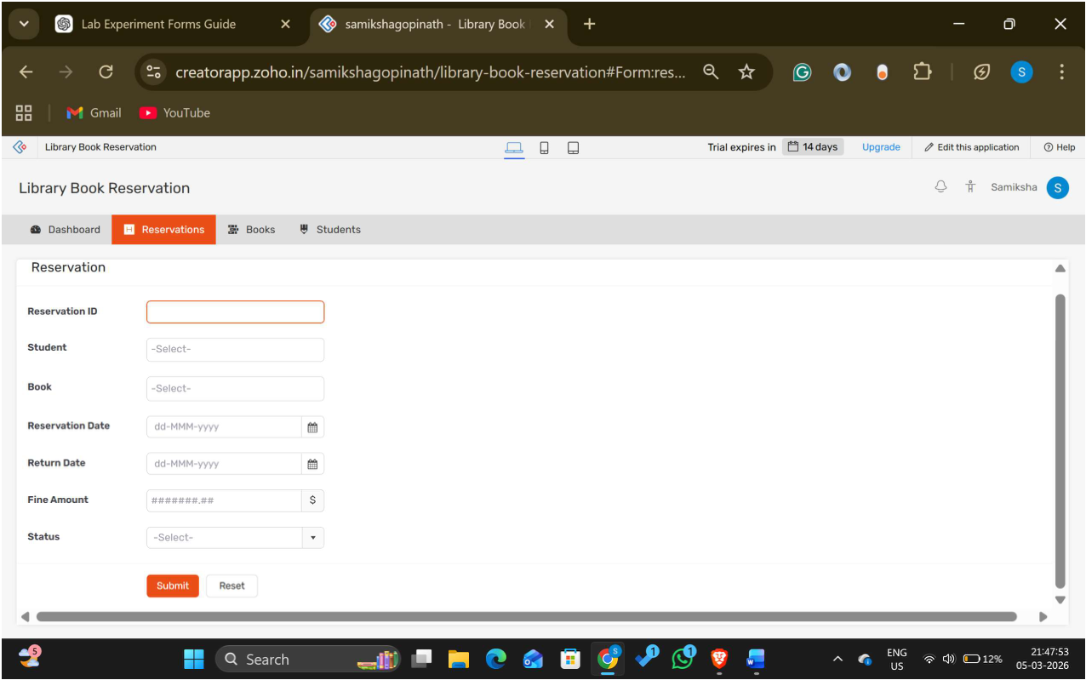
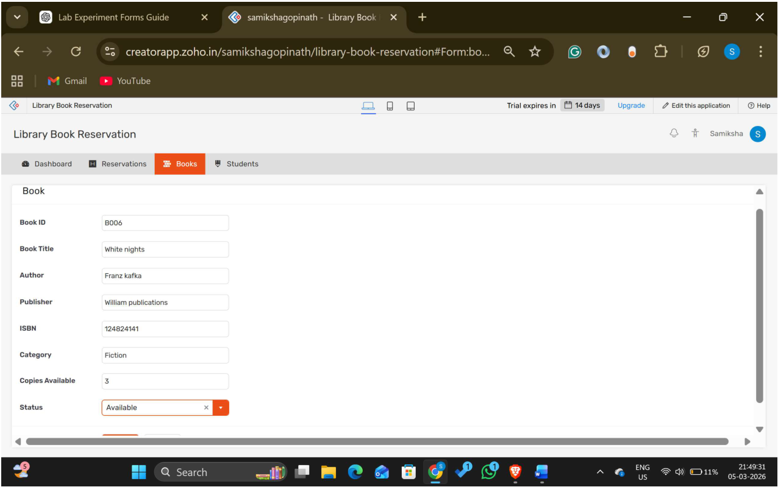
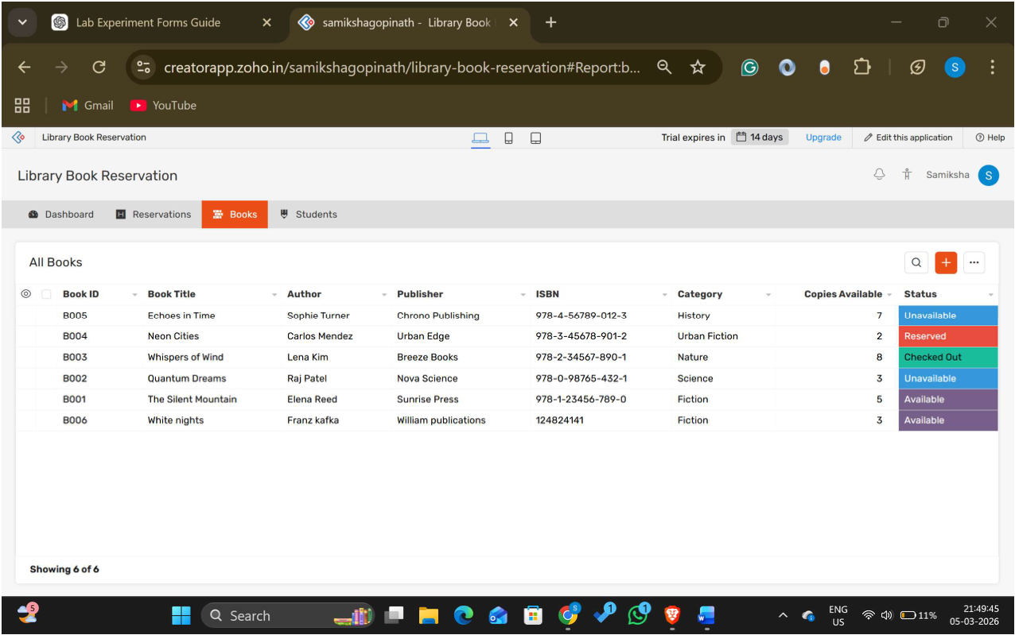

Result
A cloud-based Library Book Reservation System for the SIMATS Library was successfully developed and deployed using Zoho Creator. The application enabled students and librarians to manage book reservations efficiently through a web browser, demonstrating the Software as a Service (SaaS) model by providing secure, online access without requiring local software installation.

